Week 8

1)

// Write a JavaFX application program to do the following:
// Display the message “Welcome to JavaFX programming” using Label in the Scene.
// Set the text color of the Label to Magenta.
// Set the title of the Stage to “This is the first JavaFX Application”.
// Set the width and height of the Scene to 500 and 200 respectively.
// Use FlowPane layout and set the hgap and vgap of the FlowPane to desired values.
// The program will accept an integer from the user in a text field and
// display the multiplication table (up to number *10) for that number.

import javafx.application.*;
import javafx.scene.*;
import javafx.stage.*;
import javafx.scene.layout.*;
import javafx.scene.control.*;
import javafx.scene.paint.Color;

public class JavaFxQ1 extends Application
{
public static void main(String args[])
{
launch(args);
}
public void start(Stage myStage)
{
myStage.setTitle("This is the first JavaFX application");
FlowPane rootnode= new FlowPane();
rootnode.setHgap(200);
rootnode.setVgap(100);

Scene myScene=new Scene(rootnode,500,200);
myStage.setScene(myScene);

Label label=new Label("Welcome to javafx programming");
label.setTextFill(Color.MAGENTA);
rootnode.getChildren().add(label); myStage.show();
}
}

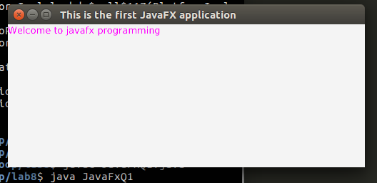

import java.util.*;
import javafx.application.*;
import javafx.scene.control.*;
import javafx.stage.Stage;
import javafx.scene.Scene;
import javafx.scene.layout.*;
import javafx.event.*;
import javafx.scene.paint.Color;
import javafx.geometry.*;

public class l8q1f extends Application
{
public void start(Stage myStage)
{
myStage.setTitle("Multiplication table generator");
FlowPane rootNode = new FlowPane(Orientation.VERTICAL,10,10);
rootNode.setAlignment( Pos.CENTER );
Label response = new Label();
Scene myScene = new Scene( rootNode, 500, 300 );
TextField tf = new TextField();
tf.setPromptText("Enter multiplicant");
tf.setOnAction(new EventHandler<ActionEvent>()
{
public void handle(ActionEvent ae)
{
final String resp=Multiply.calculate(Integer.parseInt(tf.getText()));
response.setText(resp);
}
}
);

rootNode.getChildren().addAll(tf,response);
myStage.setScene( myScene);
myStage.show();
}
public static void main(String args[])
{
launch(args);
}
}

class Multiply
{
int a;
static String calculate(int a)
{
String s = new String();
for(int i = 1; i < 11; i++)
{
s = s + "\n";
s= s+ a + "*" +i + "="+ a*i;
}
return s;
}
}

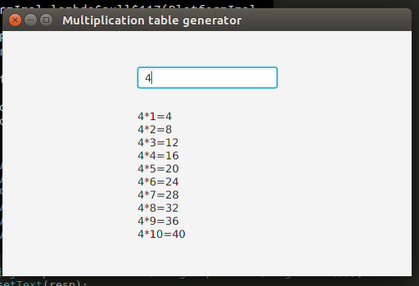

2)

// Write a JavaFX program to display a window as shown below.
// Use TextField for UserName and PasswordField for Password input.
// On click of “Sign in” Button the message “Welcome UserName” should be displayed in a Text Control.
// Use GridPane layout for the application

import java.util.*;
import javafx.application.*;
import javafx.scene.control.*;
import javafx.stage.Stage;
import javafx.scene.Scene;
import javafx.scene.layout.*;
import javafx.event.*;
import javafx.scene.paint.Color;
import javafx.geometry.*;

public class l8q2 extends Application{
public void start(Stage myStage){

myStage.setTitle("JavaFX Welcome");

GridPane rootNode= new GridPane();

myStage.setTitle("Welcome");

rootNode.setAlignment( Pos.CENTER );
Label response =new Label();
Scene myScene = new Scene( rootNode, 300, 200 );
Label label1= new Label();
Label label2= new Label();
Label label3= new Label();
label1.setText("UserName");
label2.setText("Password");

TextField textField= new TextField();

PasswordField passwordField = new PasswordField();

textField.setPromptText("User Name");

passwordField.setPromptText("Password");

Button btn1=new Button("Sign In");

btn1.setOnAction(new EventHandler<ActionEvent>(){
public void handle(ActionEvent ae){
label3.setText("Welcome "+textField.getText());
}
});
rootNode.add(label1, 0, 0, 1, 1);
rootNode.add(label2, 0, 1, 1, 1);
rootNode.add(textField, 1, 0, 1, 1);
rootNode.add(passwordField, 1, 1, 1, 1);
rootNode.add(label3, 0, 2, 1, 1);
rootNode.add(btn1, 1, 2, 1, 1);

myStage.setScene(myScene);
myStage.show();
}

public static void main(String args[]){
launch(args);
}
}

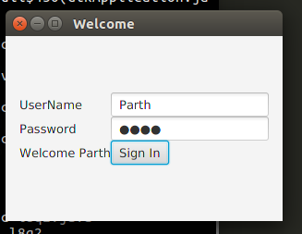

3)

// Write a JavaFX application program that obtains two floating point numbers in two text fields
// from the user and displays the sum, product, difference and quotient of these numbers
// using Canvas on clicking compute button with a calculator image placed on it

import javafx.application.Application;
import javafx.scene.Scene;
import javafx.scene.control.*;
import javafx.scene.layout.*;
import javafx.event.ActionEvent;
import javafx.event.EventHandler;
import javafx.scene.control.Label;
import javafx.stage.Stage;
import javafx.scene.image.*;
import javafx.scene.paint.Color;
import javafx.geometry.Insets;
import javafx.geometry.Pos;
import javafx.scene.canvas.*;
import javafx.scene.image.ImageView;
import javafx.scene.image.Image;
import java.io.FileInputStream;
import java.io.*;

public class l8q3 extends Application {
float num1, num2;

public void start(Stage s) throws Exception{
s.setTitle("Calculator");
s.setWidth(500);
s.setHeight(500);

FileInputStream input=new FileInputStream("./calculator.jpeg");

Image image = new Image(input);
ImageView img=new ImageView(image);

img.setPreserveRatio(true);
img.setFitHeight(30);

Label b = new Label("Welcome");
TextField tfnum1 = new TextField("");
Label lbnum1 = new Label("Number 1: ");
lbnum1.setLabelFor(tfnum1);
TextField tfnum2 = new TextField("");
Label lbnum2 = new Label("Number 2: ");
lbnum2.setLabelFor(tfnum2);
Label sum = new Label();
Label product = new Label();
Label difference = new Label();
Label quotient = new Label();
sum.setVisible(false);
product.setVisible(false);
difference.setVisible(false);
quotient.setVisible(false);
Button btn = new Button();
btn.setGraphic(img);

btn.setOnAction(new EventHandler<ActionEvent>() {
@Override
public void handle(ActionEvent arg0) {
try{
num1 = Float.parseFloat(tfnum1.getText());
num2 = Float.parseFloat(tfnum2.getText());
sum.setText(String.format(" Sum = %f", num1+num2));
product.setText(String.format(" Product = %f", num1*num2));
difference.setText(String.format(" Difference = %f", num1-num2));
quotient.setText(String.format(" Quotient = %f", num1/num2));

sum.setVisible(true);
product.setVisible(true);
difference.setVisible(true);

quotient.setVisible(true);
}catch(java.lang.NumberFormatException ex){
System.out.println("NumberFormatException");
}
}
}
);

Canvas can = new Canvas(300.0f, 300.0f);
GraphicsContext gc = can.getGraphicsContext2D();
gc.setFill(Color.WHITE);
gc.fillRect(0, 0, 300, 300);
GridPane l = new GridPane();

l.setPadding(new Insets(10, 10, 10, 10));
l.setVgap(5);
l.setHgap(5);
l.setAlignment(Pos.BASELINE_LEFT);
l.add(sum, 0, 0);
l.add(product, 0, 1);
l.add(difference, 0, 2);
l.add(quotient, 0, 3);

StackPane n = new StackPane();
n.getChildren().addAll(can, l);
GridPane r = new GridPane();
r.setMinSize(500, 200);

r.setPadding(new Insets(10, 10, 10, 10));
r.setVgap(5);
r.setHgap(5);
r.setAlignment(Pos.BASELINE_LEFT);
r.add(b, 0, 0);
r.add(lbnum1, 0, 1);
r.add(tfnum1, 1, 1);
r.add(lbnum2, 0, 2);
r.add(tfnum2, 1, 2);
r.add(btn, 2, 3);
r.add(n, 0, 5, 2, 5);
Scene sc = new Scene(r, 200, 200);
s.setScene(sc);
s.show();
}

public static void main(String args[]){
launch(args);
}

}

